**DAILY ONLINE ACTIVITIES SUMMARY**

|  |  |  |  |  |  |  |  |
| --- | --- | --- | --- | --- | --- | --- | --- |
| **Date:** | **22/05/2020** | | | | **Name:** | **Ravi K R** | |
| **Sem & Sec** | **8th- B** | | | | **USN:** | **4AL16CS076** | |
| **Online Test Summary** | | | | | | | |
| **Subject** | | **BDA** | | | | | |
| **Max. Marks** | | **40** | | **Score** | | **28** | |
| **Certification Course Summary** | | | | | | | |
| **Course** | **Spring Framework Getting Started And Dependency Injection Fundamentals Tutorial For Real World Application Development** | | | | | | |
| **platform** | | | **udemy** | **Duration** | | | **2 hrs** |
| **Coding Challenges** | | | | | | | |
| **Problem Statement:**  **1)** Java program to demonstrate working of Collections.sort() | | | | | | | |
| **Status: Executed** | | | | | | | |
| **Uploaded the report in Github** | | | | **Yes** | | | |
| **If yes Repository name** | | | | <https://github.com/Ravikr973161/certification-Programming> | | | |
| **Uploaded the report in slack** | | | | **Yes** | | | |

Online Test Details: 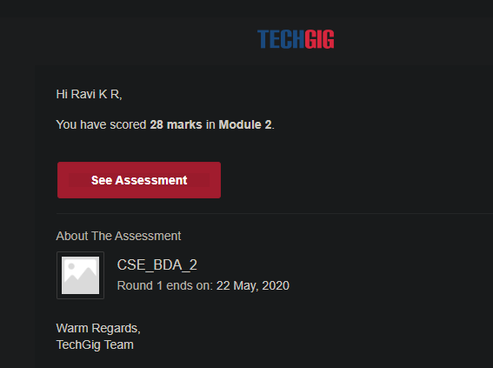

Certification:

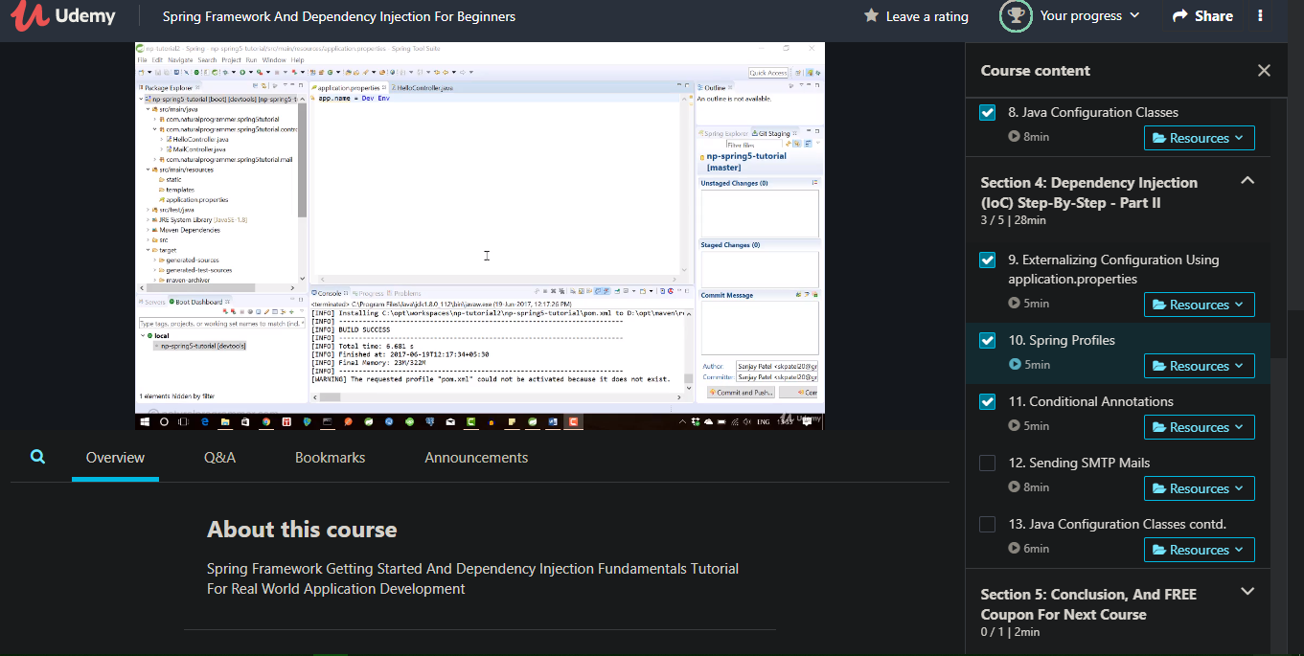

Coding Challenges Details:

// Java program to demonstrate working of Collections.sort()

|  |
| --- |
| // Java program to demonstrate working of Comparator  // interface and Collections.sort() to sort according  // to user defined criteria.  import java.util.*;  import java.lang.*;  import java.io.*;    // A class to represent a student.  class Student  {      int rollno;      String name, address;        // Constructor      public Student(int rollno, String name,                                 String address)      {          this.rollno = rollno;          this.name = name;          this.address = address;      }        // Used to print student details in main()      public String toString()      {          return this.rollno + " " + this.name +                             " " + this.address;      }  }    class Sortbyroll implements Comparator<Student>  {      // Used for sorting in ascending order of      // roll number      public int compare(Student a, Student b)      {          return a.rollno - b.rollno;      }  }    // Driver class  class Main  {      public static void main (String[] args)      {          ArrayList<Student> ar = new ArrayList<Student>();          ar.add(new Student(111, "bbbb", "london"));          ar.add(new Student(131, "aaaa", "nyc"));          ar.add(new Student(121, "cccc", "jaipur"));            System.out.println("Unsorted");          for (int i=0; i<ar.size(); i++)              System.out.println(ar.get(i));            Collections.sort(ar, new Sortbyroll());            System.out.println("\nSorted by rollno");          for (int i=0; i<ar.size(); i++)              System.out.println(ar.get(i));      }  } |